Marketing Research

Wireless Bluetooth Headphone
- Skullcandy Crusher Evo Wireless Bluetooth Headphones with Multi-Sensory Bass, Noise Isolating Over-Ear Fit, Up to 40 Hours Battery, Microphone for iPhone Android - Chill Grey
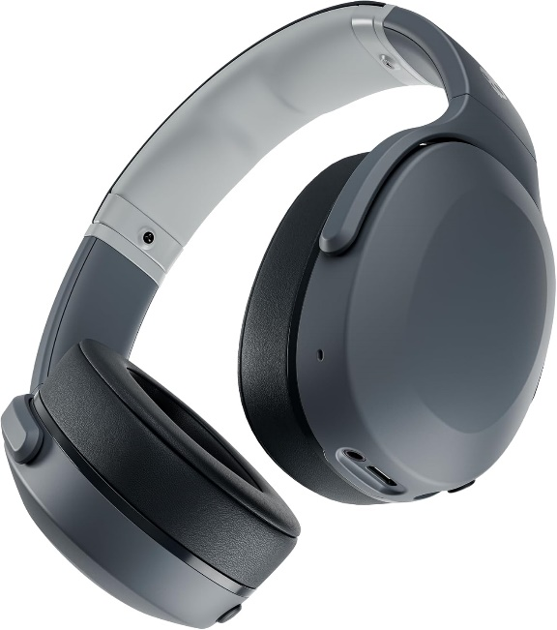

Price – LKR 54,348
Color: Chill Grey
Brand | Skullcandy
Color | Chill Grey
Ear Placement | Over Ear
Form Factor | Over Ear
Impedance | 32 Ohms

About this item
- PATENTED MULTI-SENSORY CRUSHER BASS TECHNOLOGY.
Featuring two full-range 40mm audio drivers plus additional dual bass drivers, your music and movies will come alive with a sound experience you can actually feel
- UP TO 40 HOURS BATTERY + RAPID CHARGE.
Listen to your music for days with up to 40 hours of battery life. With Rapid Charge, just 10 minutes of charging gives you 4 hours of listening
- PERSONAL SOUND IN THE SKULLCANDY APP.
Download the app and participate in a hearing analysis that automatically adjusts the sound levels for your specific hearing
- CALL, TRACK AND VOLUME CONTROLS.
Answer or reject calls, adjust volume, skip forward or repeat tracks with convenient button controls
- FLAT-FOLDING AND COLLAPSIBLE DESIGN.
For enhanced headphone portability and convenience without sacrificing durability
- BUY WITH CONFIDENCE.
Skullcandy 1-Year USA Limited Warranty included

Customer reviews

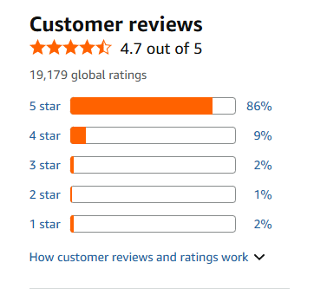

https://www.amazon.com/Skullcandy-Bluetooth-Headphones-Multi-Sensory-Microphone/dp/B08FCGLYFZ/ref=sxin_17_pa_sp_search_thematic-asin_sspa?content-id=amzn1.sym.44342f3a-a64c-4ea5-abec-0bebc4593173%3Aamzn1.sym.44342f3a-a64c-4ea5-abec-0bebc4593173&crid=2BQQKL0TJAKL8&cv_ct_cx=headset&keywords=headset&pd_rd_i=B0CPNYDXQL&pd_rd_r=f3202505-de21-4cca-b268-74dc34c49284&pd_rd_w=cPfH6&pd_rd_wg=Safkt&pf_rd_p=44342f3a-a64c-4ea5-abec-0bebc4593173&pf_rd_r=A1037E91DCA8NRTA7Q90&qid=1780382004&sbo=RZvfv%2F%2FHxDF%2BO5021pAnSA%3D%3D&sprefix=headset%2Caps%2C337&sr=1-2-baa1f287-65d3-41a3-a655-8bbba0531537-spons&aref=ZifeihAWMo&sp_csd=d2lkZ2V0TmFtZT1zcF9zZWFyY2hfdGhlbWF0aWM&th=1

- Skullcandy Crusher ANC 2 Wireless Over-Ear Bluetooth Headphones with Multi-Sensory Bass, Active Noise Cancelling, Up to 60 Hours Battery, Microphone for iPhone Android - True Black

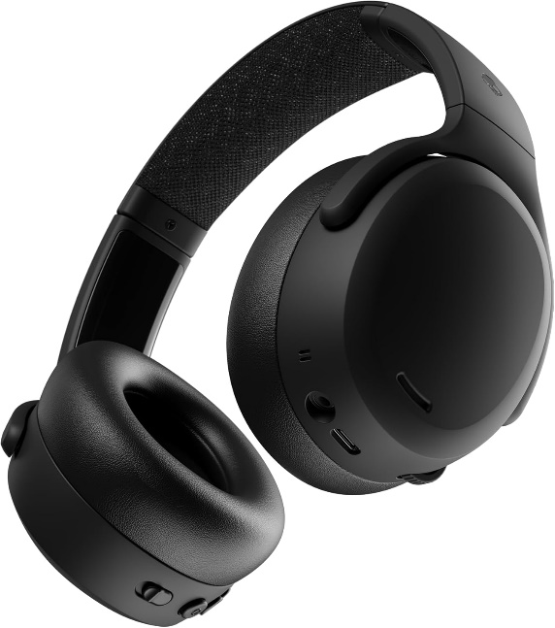

Price – LKR 70,075
Color: True Black
Brand | Skullcandy
Color | True Black
Ear Placement | Over Ear
Form Factor | Over Ear
Impedance | 32 Ohms

About this item
- PATENTED MULTI-SENSORY CRUSHER BASS TECHNOLOGY.
Featuring two full-range 40mm audio drivers plus additional dual bass drivers, your music and movies will come alive with a sound experience you can actually feel
- ADJUSTABLE 4-MIC ACTIVE NOISE CANCELLING.
Designed with adjustable 4-mic active noise canceling that allows you to hush the chaos around you
- UP TO 60 HOURS BATTERY + RAPID CHARGE.
Get hours of uninterrupted listening with up to 60 hours of battery life with ANC off. With Rapid Charge, just 10 minutes of charging gives you 4 hours of listening
- PERSONALIZED SOUND IN THE SKULLCANDY APP.
Customize your sound with Personal Sound by Mimi, adjustable hearing modes: Active Noise Canceling, Stay-Aware, and fine-tune your EQ
- MULTIPOINT PAIRING.
Connect to two devices at once with seamless transitions
- BUY WITH CONFIDENCE.
Skullcandy 1-Year USA Limited Warranty included

Customer reviews

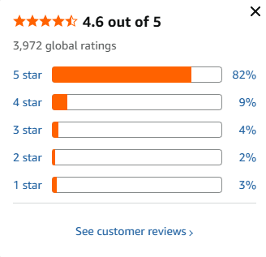
https://www.amazon.com/Skullcandy-Cancelling-Headphones-Microphone-Bluetooth/dp/B0C9L8ZR6Q/ref=sr_1_1_sspa?crid=2BQQKL0TJAKL8&dib=eyJ2IjoiMSJ9.E32DckRZB1tYZ17cEu3V0cOdFtgCbcmcfaEBrKyKxff0-3wJfz3gGr9YUyIRkiSHKFLPxyxTa8VQuGRcNXThy8JuHIxTnZf0ZNfvYl3UZlV1BnwUCUhYubTzJdC-XUzKLpz08J8P4k5ZJlTboi--ZGG-NgvkKfYvl5epa1ZTzRMcw7jXwKduCxkrH_PaOcesd9ovZ1UDAGlblZENsitZiDLXCjC-V4dDfrAYTFl9gfA.RYLrhpLQeRlCoiLILB4e3206WctnvYePOtlCJ8aLK08&dib_tag=se&keywords=headset&qid=1780382004&sprefix=headset%2Caps%2C337&sr=8-1-spons&sp_csd=d2lkZ2V0TmFtZT1zcF9hdGY&th=1

- Skullcandy Crusher ANC 2 Wireless Over-Ear Bluetooth Headphones with Multi-Sensory Bass, Active Noise Cancelling, Up to 60 Hours Battery, Microphone for iPhone Android – Leopard

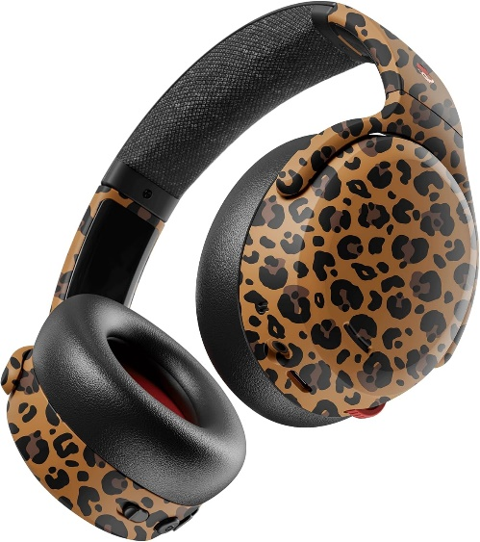

Price – LKR 78,462
Color: Leopard
Brand | Skullcandy
Color | Leopard
Ear Placement | Over Ear
Form Factor | Over Ear
Impedance | 32 Ohms

About this item
- PATENTED MULTI-SENSORY CRUSHER BASS TECHNOLOGY.
Featuring two full-range 40mm audio drivers plus additional dual bass drivers, your music and movies will come alive with a sound experience you can actually feel
- ADJUSTABLE 4-MIC ACTIVE NOISE CANCELLING.
- Designed with adjustable 4-mic active noise canceling that allows you to hush the chaos around you
- UP TO 60 HOURS BATTERY + RAPID CHARGE.
Get hours of uninterrupted listening with up to 60 hours of battery life with ANC off. With Rapid Charge, just 10 minutes of charging gives you 4 hours of listening
- PERSONALIZED SOUND IN THE SKULLCANDY APP.
Customize your sound with Personal Sound by Mimi, adjustable hearing modes: Active Noise Canceling, Stay-Aware, and fine-tune your EQ
- MULTIPOINT PAIRING.
Connect to two devices at once with seamless transitions

Customer reviews
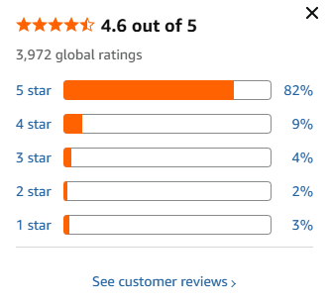
https://www.amazon.com/Skullcandy-Headphones-Multi-Sensory-Cancelling-Microphone/dp/B0G39X5N25/ref=sxin_17_pa_sp_search_thematic-asin_sspa?content-id=amzn1.sym.44342f3a-a64c-4ea5-abec-0bebc4593173%3Aamzn1.sym.44342f3a-a64c-4ea5-abec-0bebc4593173&crid=2BQQKL0TJAKL8&cv_ct_cx=headset&keywords=headset&pd_rd_i=B0G39X5N25&pd_rd_r=f3202505-de21-4cca-b268-74dc34c49284&pd_rd_w=cPfH6&pd_rd_wg=Safkt&pf_rd_p=44342f3a-a64c-4ea5-abec-0bebc4593173&pf_rd_r=A1037E91DCA8NRTA7Q90&qid=1780382004&sbo=RZvfv%2F%2FHxDF%2BO5021pAnSA%3D%3D&sprefix=headset%2Caps%2C337&sr=1-4-baa1f287-65d3-41a3-a655-8bbba0531537-spons&aref=kEy3pclBsr&sp_csd=d2lkZ2V0TmFtZT1zcF9zZWFyY2hfdGhlbWF0aWM&th=1

- Sony WH-1000XM5 Premium Noise Canceling Headphones, Auto NC Optimizer, 30-Hour Battery, Alexa Voice Control, Black

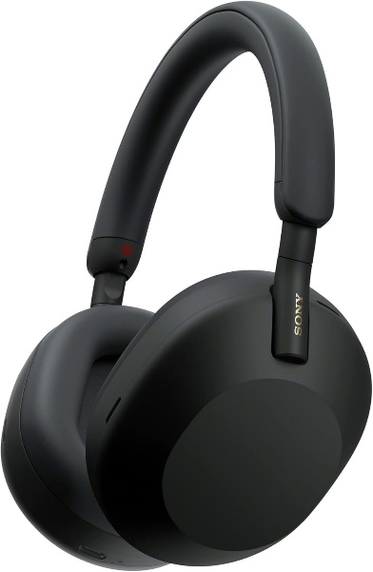

Price – LKR 82,212
Brand | Sony
Color | Black
Ear Placement | Over Ear
Form Factor | Over Ear
Impedance | 48 Ohms
Color: Black

About this item
- NOISE CANCELLATION:
Immerse yourself in the world of music with these noise cancelling headphones, the Sony WH-1000XM5. They come equipped with an advanced noise cancellation feature, powered by two processors controlling eight microphones. Experience the magic of noise cancelling headphones bluetooth technology, ensuring an uninterrupted listening experience free from external disturbances. This unique, distraction-free listening experience sets the Sony WH-1000XM5 apart from other headphones in the market.
- HANDS-FREE CALLING:
Step into the future of communication with the Sony WH-1000XM5, a pair of over-ear headphones that make crystal clear hands-free calling a reality. They come equipped with four beamforming microphones and advanced audio signal processing. These over ear headphones ensure your voice is heard clearly, even in noisy environments. This feature is a boon for professionals and individuals who value clear, crisp communication.
- LONG BATTERY LIFE:
Say goodbye to battery anxiety with the Sony WH-1000XM5, a wireless headset that offers up to 30 hours of playback time on a single charge. These head phones also feature a quick charging option that provides 3 hours of playback with just a 3-minute charge, ensuring uninterrupted music enjoyment. (USB Type-C Cable included)
- COMFORT & STYLE:
Experience the perfect blend of comfort and style with the Sony WH-1000XM5's lightweight design and soft fit leather. These headphones are designed for maximum comfort, allowing you to wear them for extended periods without any discomfort. Sound quality and comfort go hand in hand with these headphones, making them an ideal choice for music lovers.
- TOUCH CONTROLS:
Take control of your music with the Sony WH-1000XM5's intuitive touch controls. With a simple touch, you can pause, play, skip tracks, control volume, activate your voice assistant, and answer phone calls. This feature makes the Sony WH-1000XM5 a must-have for those who value convenience and control.

Customer reviews
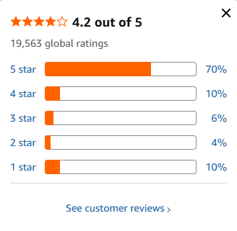

https://www.amazon.com/dp/B09XS7JWHH/ref=sspa_dk_detail_5?pd_rd_i=B09XS7JWHH&pd_rd_w=6vxh8&content-id=amzn1.sym.85ceacba-39b1-4243-8f28-2e014f9512c7&pf_rd_p=85ceacba-39b1-4243-8f28-2e014f9512c7&pf_rd_r=5HN7D4J5T3JGQCPD8ZMR&pd_rd_wg=p2dfd&pd_rd_r=0aa6a0ea-cff9-4f15-bd31-f4677e11b2e7&sp_csd=d2lkZ2V0TmFtZT1zcF9kZXRhaWxfdGhlbWF0aWM&th=1

- Skullcandy Hesh ANC Wireless Over-Ear Bluetooth Headphones, Active Noise Cancelling, Up to 22 Hrs Battery, Foldable Lightweight Design, Microphone for iPhone Android - Preppy Sage
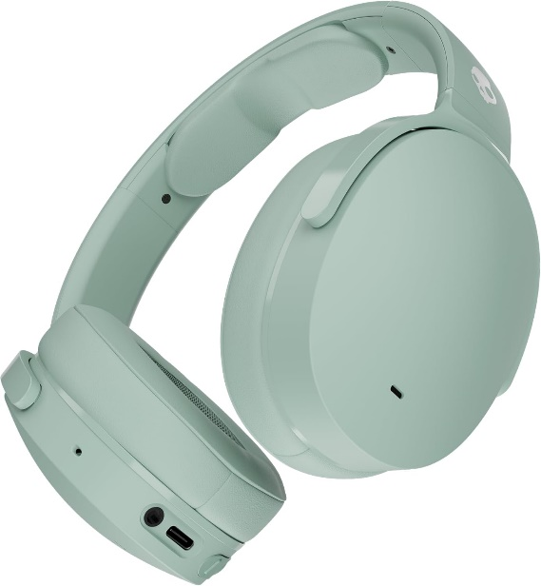

Price – LKR 31,555
Color: Preppy Sage
Brand | Skullcandy
Color | Preppy Sage
Ear Placement | Over Ear
Form Factor | Over Ear
Impedance | 32 Ohms

About this item
- 4-MIC ACTIVE NOISE CANCELLING.
Designed with 4-mic active noise canceling that lets you lose yourself in your music, movies or podcasts
- UP TO 22 HOURS BATTERY + RAPID CHARGE.
With Rapid Charge, just 10 minutes of charging gives you 3 hours of listening
- CALL, TRACK AND VOLUME CONTROLS.
Answer or reject calls, adjust volume, skip forward or repeat tracks with convenient button controls
- BUILT-IN TILE FINDING TECHNOLOGY.
Find your headphones near and far when you register your product in the Tile App
- FLAT-FOLDING AND COLLAPSIBLE DESIGN.
For enhanced headphone portability and convenience without sacrificing durability
- BUY WITH CONFIDENCE.
Skullcandy 1-Year USA Limited Warranty included
Customer Reviews

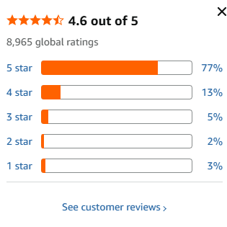
https://www.amazon.com/dp/B0DVH63P58/ref=sspa_dk_detail_2?pd_rd_i=B0DVH63P58&pd_rd_w=O3FeW&content-id=amzn1.sym.ac210bc5-f6e8-418c-8a77-e0c4ca3bcd7f&pf_rd_p=ac210bc5-f6e8-418c-8a77-e0c4ca3bcd7f&pf_rd_r=RNTGYJJP4XRGR7VHQJTN&pd_rd_wg=dj7cH&pd_rd_r=c31fbf80-e291-4467-85f3-83b409777d45&sp_csd=d2lkZ2V0TmFtZT1zcF9kZXRhaWw&th=1

- Skullcandy Crusher PLYR 720 Wireless Gaming Headset, Ultimate Immersion and Comfort, THX Spatial Audio, Multi-Sensory Bass and Platform- Digi-Black, Removable Mic, PC, PlayStation, Nintendo

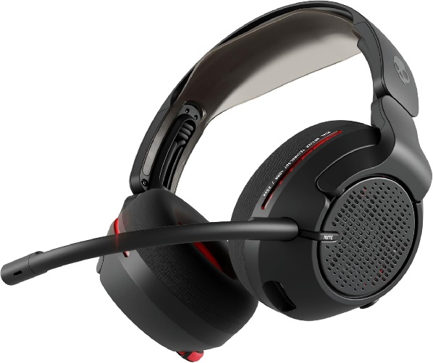

Price – LKR 66,296
Color: Digi-Black

Brand | Skullcandy
Color | Digi-Black
Ear Placement | Over Ear
Form Factor | Over Ear
Impedance | 36 Ohms

About this item
- PATENTED MULTI-SENSORY CRUSHER BASS TECHNOLOGY.
Crusher Bass is the closest thing to living the game. Featuring two full-range 40mm audio drivers plus additional dual bass drivers, Skullcandy’s first-ever gaming headset featuring Crusher Bass will deliver a sound experience you can actually feel.
- THX SPATIAL AUDIO WITH HEAD TRACKING.
Transport yourself into the digital world with fully immersive, 360-degree sound. Experience depth as sounds move around you — get lost in hyper-realistic sound.
- DIAL IT IN.
Use Skull-HQ desktop app or Skullcandy mobile app to customize game-play and audio controls. Fine-tune advanced features for the ultimate gaming audio experience. From RGB headset settings, Crusher EQ customizer, THX Spatial Audio controls to a personalized Enhanced Sound Perception, and more.
- NATURAL SOUND IMMERSION.
Crusher PLYR 720’s open-back design lets air flow freely for natural sound and incredible audio precision. It also lets heat escape to keep you cool and comfortable for marathon gaming sessions.
- DESIGNED FOR SUPERNATURAL COMFORT.
Designed with ultra-soft memory foam and heat-absorbing ear cushions, and a custom suspension headband that adapts to every head shape for a weightless, balanced feel. Game all day, everyday.
- MULTI-PLATFORM COMPATIBILITY.
Connects to Nintendo Switch, PC and Mobile via Bluetooth. Or, wirelessly connect to PlayStation, Nintendo Switch and PC via the USB-A Ultra-Low Latency Wireless Transmitter. Hear every sound with no delay on 25ms fast wireless audio transmission.
- BUY WITH CONFIDENCE.
Skullcandy 1-Year USA Limited Warranty included.

Customer Reviews
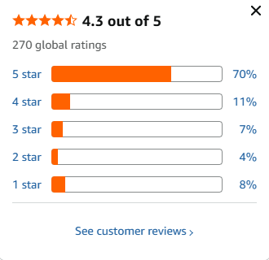
https://www.amazon.com/dp/B0DWD3GVJL/ref=sspa_dk_detail_4?pd_rd_i=B0DWD3GVJL&pd_rd_w=m9VXp&content-id=amzn1.sym.85ceacba-39b1-4243-8f28-2e014f9512c7&pf_rd_p=85ceacba-39b1-4243-8f28-2e014f9512c7&pf_rd_r=RNTGYJJP4XRGR7VHQJTN&pd_rd_wg=dj7cH&pd_rd_r=c31fbf80-e291-4467-85f3-83b409777d45&sp_csd=d2lkZ2V0TmFtZT1zcF9kZXRhaWxfdGhlbWF0aWM&th=1

- Skullcandy Hesh 540 ANC Wireless Over-Ear Bluetooth Headphones with THX Spatial Audio, Active Noise Cancelling, Personalized Sound, Up to 65 Hours Battery, Microphone for iPhone Android – Bone

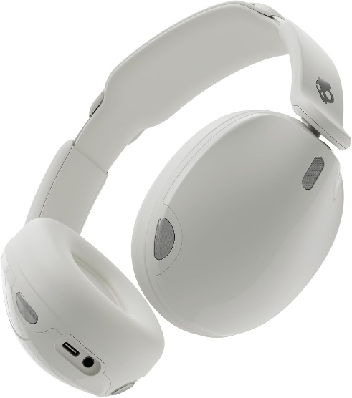

Price – LKR 33,146
Color: Bone

Brand | Skullcandy
Color | Bone
Ear Placement | Over Ear
Form Factor | Over Ear
Impedance | 36 Ohms

About this item
- PREMIUM ACTIVE NOISE CANCELLING.
Hesh 540 ANC uses adjustable 4-mic noise cancelling to silence the world around you.
- UP TO 65 HOURS BATTERY + RAPID CHARGE.
Listen to your tunes all-day long with up to 65 hours of battery life with ANC off. Our Rapid Charge feature gives you 4 hours of listening on a quick 10-minute charge.
- THX SPATIAL AUDIO.
Experience your audio like never before with fully immersive, 3-dimensional sound. It’s not just hearing music or movies, it’s feeling every detail like you’re right there in the moment.
- WEAR DETECTION.
Never miss a beat. With wear detection, your audio will auto-pause when you take your headphones off and auto-play when you put your headphones on.
- PERSONALIZED SOUND IN THE SKULLCANDY APP.
Customize your sound with THX Spatial Audio, Personal Sound by Mimi, adjustable hearing modes: Active Noise Canceling, Stay-Aware and Sidetone settings, and more.

Customer Reviews
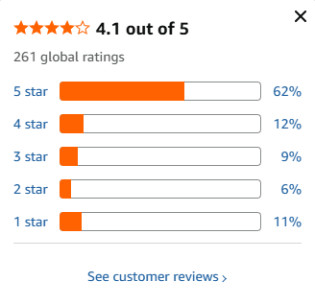
https://www.amazon.com/dp/B0FJ4CQ994/ref=sspa_dk_detail_2?pd_rd_i=B0FJ4CQ994&pd_rd_w=igjQi&content-id=amzn1.sym.85ceacba-39b1-4243-8f28-2e014f9512c7&pf_rd_p=85ceacba-39b1-4243-8f28-2e014f9512c7&pf_rd_r=DHTDKX2AWKQ531H5G1NT&pd_rd_wg=2qBKc&pd_rd_r=96d46333-696b-4fcc-8caa-9635699b8b1c&sp_csd=d2lkZ2V0TmFtZT1zcF9kZXRhaWxfdGhlbWF0aWM&th=1

- Skullcandy Crusher ANC 2 Wireless Over-Ear Bluetooth Headphones with Multi-Sensory Bass, Active Noise Cancelling, Up to 60 Hours Battery, Microphone for iPhone Android – Plasma

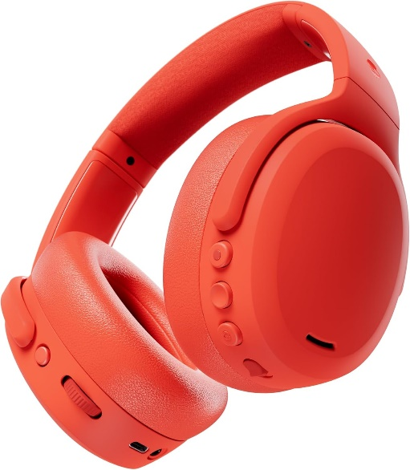

Price – LKR 79,228
Color: Plasma

Brand | Skullcandy
Color | Plasma
Ear Placement | Over Ear
Form Factor | Over Ear
Impedance | 32 Ohms

About this item
- PATENTED MULTI-SENSORY CRUSHER BASS TECHNOLOGY.
Featuring two full-range 40mm audio drivers plus additional dual bass drivers, your music and movies will come alive with a sound experience you can actually feel
- ADJUSTABLE 4-MIC ACTIVE NOISE CANCELLING.
Designed with adjustable 4-mic active noise canceling that allows you to hush the chaos around you
- UP TO 60 HOURS BATTERY + RAPID CHARGE.
Get hours of uninterrupted listening with up to 60 hours of battery life with ANC off. With Rapid Charge, just 10 minutes of charging gives you 4 hours of listening
- PERSONALIZED SOUND IN THE SKULLCANDY APP.
Customize your sound with Personal Sound by Mimi, adjustable hearing modes: Active Noise Canceling, Stay-Aware, and fine-tune your EQ
- MULTIPOINT PAIRING.
Connect to two devices at once with seamless transitions
- BUY WITH CONFIDENCE.
Skullcandy 1-Year USA Limited Warranty included

Customer Reviews
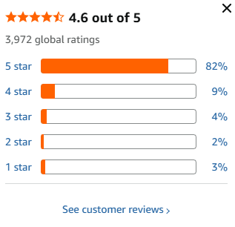
https://www.amazon.com/dp/B0F1N9YNSQ/ref=sspa_dk_detail_3?pd_rd_i=B0F1N9YNSQ&pd_rd_w=5Rs35&content-id=amzn1.sym.ac210bc5-f6e8-418c-8a77-e0c4ca3bcd7f&pf_rd_p=ac210bc5-f6e8-418c-8a77-e0c4ca3bcd7f&pf_rd_r=28EXBHWAR5ZEHK5CAC95&pd_rd_wg=ctPsc&pd_rd_r=bc0fa2f7-899a-46b5-8571-da575f5dd9d6&sp_csd=d2lkZ2V0TmFtZT1zcF9kZXRhaWw&th=1

- Monster Persona 5th ANC-Wireless Bluetooth Over-Ear Headphones with Microphone, 70H Playtime, Bluetooth 6.0, Comfortable and Foldable Design (Purple)

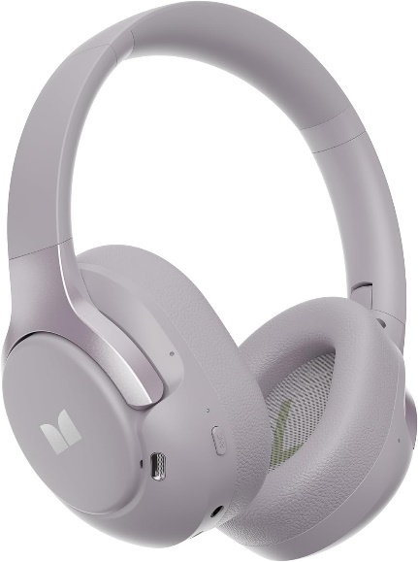

Price – LKR 16,565

Brand | Monster
Color | Purple
Form Factor | Over Ear
Noise Control | Active Noise Cancellation
Headphones Jack | 3.5 mm Jack

About this item
- HIGH-QUALITY SOUND
Superior sound quality with Active Noise Cancellation technology for precise noise reduction. Switch effortlessly between Normal, Noise Cancelling, and Transparency modes.
- UP TO 70 HOURS OF PLAYTIME
Up to 70 hours of playtime with quick charging to keep your music going. Soft, lightweight earcups and an adjustable headband ensure all-day comfort.
- MULTI-POINT CONNECTION
Connect to two Bluetooth devices simultaneously, switching effortlessly, with incoming calls automatically prioritized.
- Latest Bluetooth 6.0 &Wireless
Equipped with the latest Bluetooth 6.0 chip for fast, reliable pairing. Support both wired and wireless connections, with a built-in 3.5mm audio adapter for seamless listening.
- AFTER-SALES & USAGE SCENARIOS
Monster Persona 5th ANC is suitable for a variety of occasions such as fitness, yoga, playing games, working, etc. We provide a worry-free shopping experience, if you have any questions, please feel free to contact our 24-hour customer service, we will provide you with pre-sales and after-sales support.

Customer Reviews
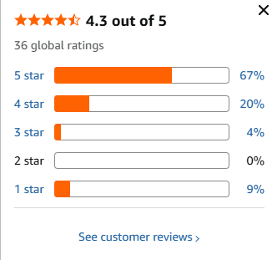

https://www.amazon.com/dp/B0GJXGM39L/ref=sspa_dk_detail_3?psc=1&pd_rd_i=B0GJXGM39L&pd_rd_w=QVNm0&content-id=amzn1.sym.85ceacba-39b1-4243-8f28-2e014f9512c7&pf_rd_p=85ceacba-39b1-4243-8f28-2e014f9512c7&pf_rd_r=79GAGD64V5FJDE660A39&pd_rd_wg=78zIR&pd_rd_r=828e2cff-2323-4bdf-9ec0-d93736cecede&sp_csd=d2lkZ2V0TmFtZT1zcF9kZXRhaWxfdGhlbWF0aWM

- Skullcandy Hesh ANC Wireless Over-Ear Bluetooth Headphones, Active Noise Cancelling, Up to 22 Hrs Battery, Foldable Lightweight Design, Microphone for iPhone Android - Mod White

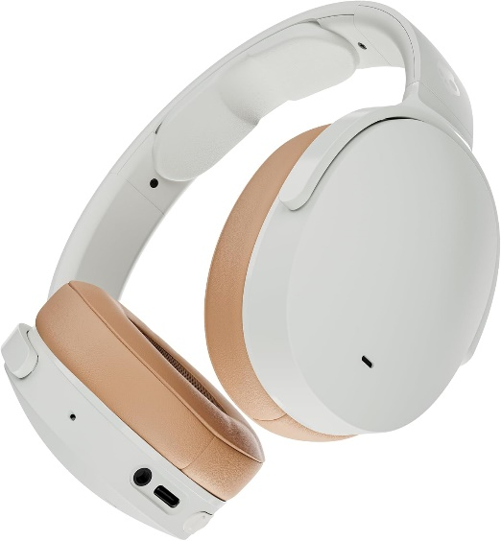

Price – LKR 42,760

Brand | Skullcandy
Color | Mod White
Ear Placement | Over Ear
Form Factor | Over Ear
Impedance | 32 Ohms

About this item
- 4-MIC ACTIVE NOISE CANCELLING.
Designed with 4-mic active noise canceling that lets you lose yourself in your music, movies or podcasts
- UP TO 22 HOURS BATTERY + RAPID CHARGE.
With Rapid Charge, just 10 minutes of charging gives you 3 hours of listening
- CALL, TRACK AND VOLUME CONTROLS.
Answer or reject calls, adjust volume, skip forward or repeat tracks with convenient button controls
- BUILT-IN TILE FINDING TECHNOLOGY.
Find your headphones near and far when you register your product in the Tile App
- FLAT-FOLDING AND COLLAPSIBLE DESIGN.
For enhanced headphone portability and convenience without sacrificing durability
- BUY WITH CONFIDENCE.
Skullcandy 1-Year USA Limited Warranty included

Customer Reviews
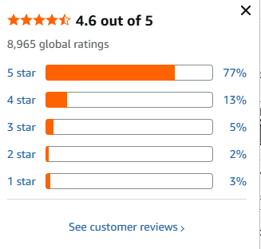

https://www.amazon.com/dp/B08G1XKY6N/ref=sspa_dk_detail_3?pd_rd_i=B08G1XKY6N&pd_rd_w=zRToy&content-id=amzn1.sym.af2be12d-373e-4c68-a933-d40df60554fe&pf_rd_p=af2be12d-373e-4c68-a933-d40df60554fe&pf_rd_r=GH5E9EF2GDMJ6WES160D&pd_rd_wg=vXGQc&pd_rd_r=bc41997b-2def-49ca-b50d-64c0aad5b7bf&sp_csd=d2lkZ2V0TmFtZT1zcF9kZXRhaWxfdGhlbWF0aWM&th=1

